**8 SCIENCE INVESTIGATION 2016**

OBSERVING HEART RATE OR BREATHING RATE

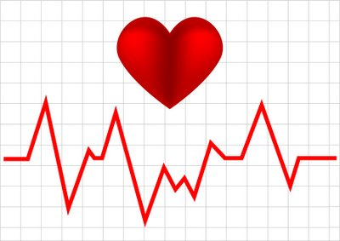

Name:_______________________ Teacher:____________________

Form:_______________________ Due date:___________________

**Plagiarism**

You must write in your own words, not copy sentences word for word from another student or another source.

Plagiarising = instant zero on assignment and you will have to re-do it.

**Assessment policy**

Give me a sick note/legitimate reason from parent BEFORE due date = new negotiated due date.

One day late = -20% taken off mark

Two days late = -40% taken off mark

Three days late = mark of zero given

After three days, students are required to attend a detention and are still required to submit the assignment.

**Introduction:** Your body systems do not work independently. Each one relies on and affects the other. Your group will design and perform an experiment to work out a way to either increase or decrease breathing rate or heart rate and see what happens to the other. You want to find out how breathing rate and heart rate are related.

Some options you could try are:

⬩ Exercise to increase the heart rate.

⬩ A period of slow, deep breathing to reduce the breathing rate.

Hint: you will need to repeat the experiment 2-4 times to obtain an average.

**Background research**

Is your group investigating heart rate or breathing rate? _________________________________________________

Describe how you will measure heart rate/breathing rate during your investigation. Include the unit of measurement you will use to measure heart rate or breathing rate. (2 marks)

_______________________________________________________________________________

_______________________________________________________________________________

_______________________________________________________________________________

_______________________________________________________________________________

_______________________________________________________________________________

_______________________________________________________________________________

Research information to help you reach a hypothesis. For example, if you want to investigate whether exercise increases or decreases heart rate, or whether exercise increases or decreases breathing rate, you would find information to help you form an educated prediction of what would occur in your investigation.

(Write in **summarised dot points** – minimum of three). (3 marks)

_______________________________________________________________________________

_______________________________________________________________________________

_______________________________________________________________________________

_______________________________________________________________________________

_______________________________________________________________________________

_______________________________________________________________________________

_______________________________________________________________________________

_______________________________________________________________________________

_______________________________________________________________________________

_______________________________________________________________________________

_______________________________________________________________________________

_______________________________________________________________________________

_______________________________________________________________________________

_______________________________________________________________________________

_______________________________________________________________________________

_______________________________________________________________________________

_______________________________________________________________________________

_______________________________________________________________________________

_______________________________________________________________________________

**Title** (descriptive, not ‘biology investigation’) (1 mark)

_______________________________________________________________________________

**Aim** (one sentence that describes what you are trying to find out in the investigation) (1 mark)

_______________________________________________________________________________

_______________________________________________________________________________

**Hypothesis** (one sentence prediction including dependent and independent variables which does not use personal language like ‘I’, ‘we’)  (2 marks)

_______________________________________________________________________________

_______________________________________________________________________________

_______________________________________________________________________________

_______________________________________________________________________________

_______________________________________________________________________________

**Materials** (detailed, how many of each item that was used) (1 mark)

___________________________________ ______________________________________

___________________________________ ______________________________________

**Dependent variable**  (1 mark)

_______________________________________________________________________________

**Independent variable**  (1 mark)

_______________________________________________________________________________

**Two controlled variables** (variables kept constant throughout the experiment to keep it fair) (2 marks)

_______________________________________________________________________________

_______________________________________________________________________________

**Method** (starting from step one, list the steps that were taken) (3 marks)

_______________________________________________________________________________

_______________________________________________________________________________

_______________________________________________________________________________

_______________________________________________________________________________

_______________________________________________________________________________

_______________________________________________________________________________

_______________________________________________________________________________

_______________________________________________________________________________

_______________________________________________________________________________

_______________________________________________________________________________

_______________________________________________________________________________

_______________________________________________________________________________

_______________________________________________________________________________

_______________________________________________________________________________

_______________________________________________________________________________

_______________________________________________________________________________

_______________________________________________________________________________

_______________________________________________________________________________

_______________________________________________________________________________

_______________________________________________________________________________

_______________________________________________________________________________

_______________________________________________________________________________

_______________________________________________________________________________

_______________________________________________________________________________

_______________________________________________________________________________

_______________________________________________________________________________

_______________________________________________________________________________

_______________________________________________________________________________

**Results**

**Table** (show the results taken from experiment, trials and averages, in pencil and using a ruler) (3 marks)

**Graph** (show your group’s **average** results in a graph using a sharp lead pencil and ruler)(6 marks)

1. Is the data you are putting in your graph discrete (each piece of data does not have a relationship with each other, categories being compared are not continuous) or continuous (each piece of data is related to the next)? (1 mark)

_______________________________________________________________________________



**Discussion** (describe one mistake or error that occurred, explain how it affected the results and how it could be avoided next time)

Remember that a mistake can be avoided with care and an error is a small change to measurement that cannot be avoided (parallax error, reading error, instrument error, human reflex etc.) (3 marks)

_______________________________________________________________________________

_______________________________________________________________________________

_______________________________________________________________________________

_______________________________________________________________________________

_______________________________________________________________________________

_______________________________________________________________________________

_______________________________________________________________________________

_______________________________________________________________________________

_______________________________________________________________________________

_______________________________________________________________________________

_______________________________________________________________________________

_______________________________________________________________________________

**Conclusion** (state the result of the experiment one state whether the hypothesis was supported or not supported) (2 marks)

_______________________________________________________________________________

_______________________________________________________________________________

_______________________________________________________________________________

_______________________________________________________________________________

_______________________________________________________________________________

_______________________________________________________________________________

**Reference list**

Referenced using the APA style shown on the next page. (1 mark)

Minimum of two references. (1 mark)

_______________________________________________________________________________

_______________________________________________________________________________

_______________________________________________________________________________

_______________________________________________________________________________

_______________________________________________________________________________

_______________________________________________________________________________

_______________________________________________________________________________

_______________________________________________________________________________

_______________________________________________________________________________

_______________________________________________________________________________

_______________________________________________________________________________

_______________________________________________________________________________

Assignment is neatly written or typed. (1 mark)

Correct spelling and grammar. (1 mark)

/36

Mark as percentage: %

Teacher comment: on Seqta

**How to reference**

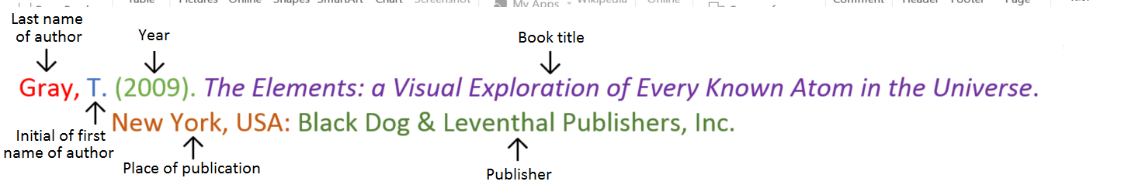**Book**

**Book with two authors**

Shermer, M., & Benjamin, A. (2006). *Secrets of Mental Math: The Mathemagician’s Guide to Lightning Calculation and Amazing Mental Math Tricks*. New York, USA: Three Rivers Press.

**Book with different editions**

Nagle, G., & Cooke, B. (2012). *Geography Study Guide: Oxford Ib Diploma Programme* (2nd ed.). Oxford, UK: Oxford University Press.

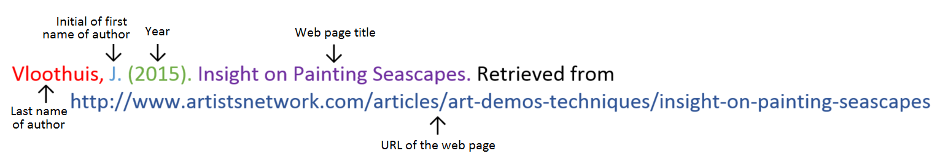**Website**

**Website with no author** (put the title from the top of the website at the front)

Aranmore Catholic College. (2014). Retrieved from http://www.aranmore.wa.edu.au/

**Website with no date** (put n.d in brackets instead of a year)

The Zadkine Museum. (n.d). Retrieved from http://www.france.fr/en/museums/zadkine-museum.html

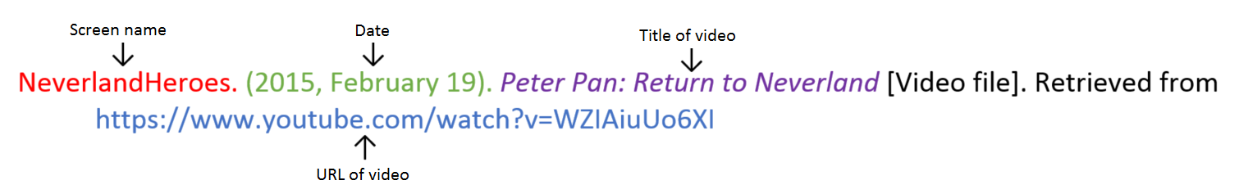**Video file**

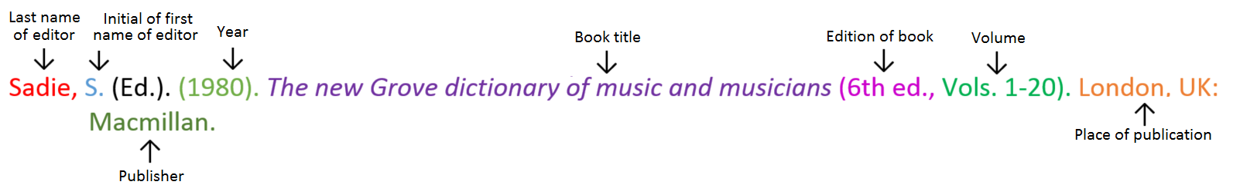**Encyclopaedia or dictionary**